PFB path to copy putty.

\\ndafile\Study Materials\BI\PuTTY

**IP address:**10.51.103.212

**Port :**22

**User :** testuser1 to testuser40

**Password :** testuser1 to testuser40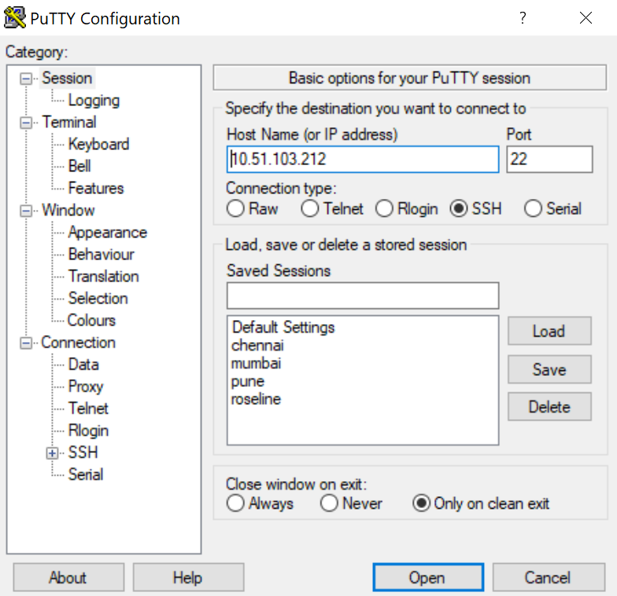

User ID and Password is testuser1 to testuser40

